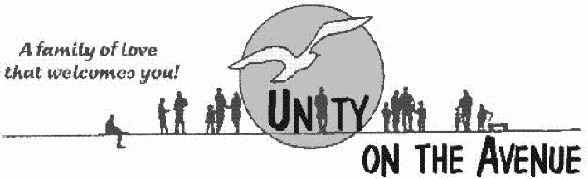

Church of Ventura

June 15th, 2012

To Whom It May Concern:

I firmly believe that Kat Knecht is one of the finest servant leaders that Unity Church of Ventura can boast. I’ve known Kat for seven years and my admiration of her practicing Truth principles in her daily life has only deepened.

Kat is one of the gems of our church. She volunteers with teaching classes; she is a coach for our Board of Trustees and is always present when I need someone to give me clarification. She is one of those rare individuals who has committed herself to make sure that this church is a success.

Kat has positive energy and enthusiasm combined with wisdom that others respect and admire. She is held in high esteem by our congregation. She has a deep sense of integrity and I trust her completely.

There are very few people I would recommend to you as confidently as Kat Knecht. She is one of the few precious gems that stand out and make a POSITIVE difference in those around her!

Blessings,

Rev. Cathy Norman

UNITY OF VENTURA 700 E MAIN ST. VENTURA, CA 93001 805-653-1059

